|  |  |
| --- | --- |
| Survey Analysis | March 16  2016 |

|  |  |  |  |
| --- | --- | --- | --- |
| **Revision record** | | | |
| Version | Date | Attendees | Comment |
| 1.0 | 16.03.16 | Arshad Shakil,  Badis Madani,  [Håkon Hedlund](https://www.facebook.com/hakon.hedlund)**,**  Zhili Shao |  |
| 1.1 | 11.04.16 | Arshad Shakil | Changed figures to only contain tables. Added enumeration of tables. Commented about the limitations of the survey software, added a comment about the type of study (quantitative/qualitative) |

Contents

1. Context of study and justification 3

2. strategies for collecting data 3

3. Survey Analysis 4

4. Summary: 7

5. Annex 8

# Context of study and justification

For the sake of studying and analyzing what users (students and employees) of the facility think of their indoor environment situation which reflect their opinions on the HVAC system operating within the facility. A survey and interviews were conducted in HSN krona building focusing on the temperature, humidity and air quality parameters, and how users perceive their comfort according to these parameters by rating it through a range of choices. They were asked to choose the most important parameters for them, and if they would like to be able regulate, what parameter and how. Some possible means of regulations were presented to them (mobile, website, panel, automatically form initial settings or fully automatic) so they have ranked them from most wanted (1) to least wanted (5). Finally, the users were asked to give any suggestions about the indoor environment.

# strategies for collecting data

Three methods were used for collecting data about the user requirements. The study is quantitative and the methods were:

* Using an online survey
* Distributing a survey on paper using the same questions as the online survey
* Interviewing the person using the questions from the online survey

|  |  |
| --- | --- |
| Survey method | Number of people |
| Online survey | 32 |
| Paper survey | 31 |
| Interview | 10 |

Table 1: DIfferent ways of gathering data

The results were fed into surveymonkey and the online application generated the statistics needed. One limitation of the online application is that it lacked the possibility to see f.ex. what females between 25 and 45 wanted and other specific statistics.

***N.B***: The physical interviews of some users were done by given paper survey and asking some questions mainly about their comfort regarding the indoor environment. So the number of people is overlapping because some of them did both (survey, interview) but we counted them only once in the final survey analysis which is 63 people in total. The duration of each interview ranged between 5 and 20 minutes.

# Survey Analysis

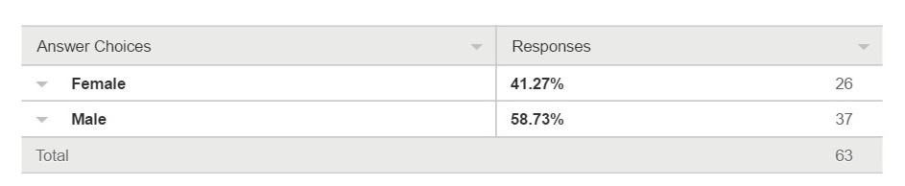***Question 2: Whats your gender?***

Table 2:Gender

The results of the survey showed that close to 60% of the asked were men. This could be explained by having asked more engineering students than others. Otherwise there is nothing else to remark about this result.

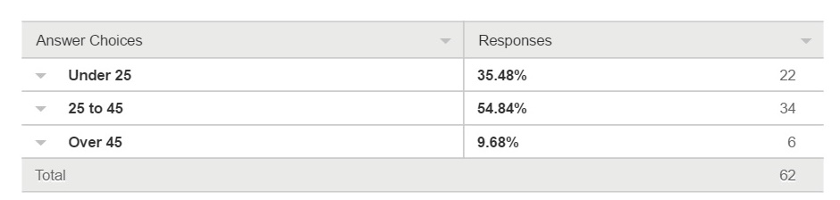***Question 2: How old are you?***

Table 3: Age

55% of the asked were aged 25 to 45 years. And approx. 35% were under 25 years of age. This means that almost 90% of the people asked were younger than 45 years old. Only six people out of the 62 asked were older than 45. Some of the surveys were given out manually to whoever was available, and that could have influenced the numbers. The survey was also posted on facebook and in groups where students were a majority. This could have influenced the numbers.

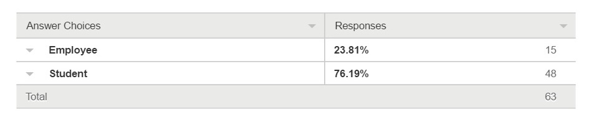***Question 3: What is your occupation?***

Table 4: Occupation

3 out of 4 asked were students. The rest were employees. This could come from asking people on facebook to answer the survey, which resulted in a surplus of students responding.

***Question 4: Are you satisfied with your indoor environment (temperature, humidity, air quality) like office, classroom?***

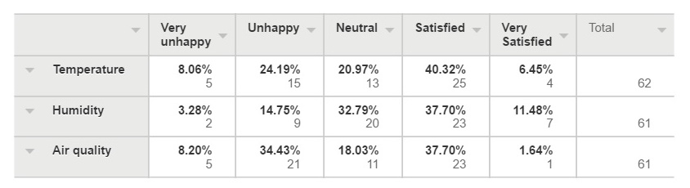

Table 5: Table showing how satisfied they are with indoor environment

Out of the 62 asked, only 38 to 49% were satisfied or very satisfied with either temperature, humidity or air quality. On the other hand, 18 to 42% were unhappy or very unhappy with the same parameters, where air quality scored was 42%. On average approximately 1 out of 4 were neutral to indoor environment. The overall impression is that there is a need for improving the quality of the indoor environment.

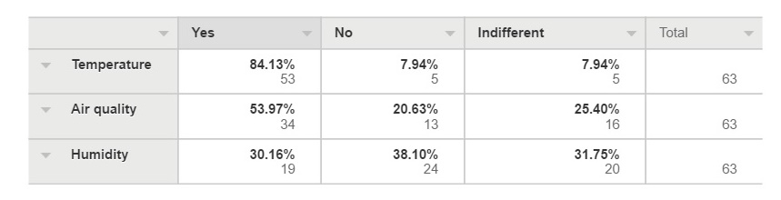***Question 5: Do you prefer to be able to regulate them by yourself?***

Table 6: Table showing if they would want to regulate the indoor environment

More than 84% wanted to regulate the temperature, 53% wanted to regulate the air quality, and only 30% wanted to regulate the humidity. This shows that even though many might be satisfied with the indoor environment, they want to be able to regulate it themselves also.

***Question 6: How do you want to regulate? Please rank them from the most wanted 1 to the least wanted 5.***

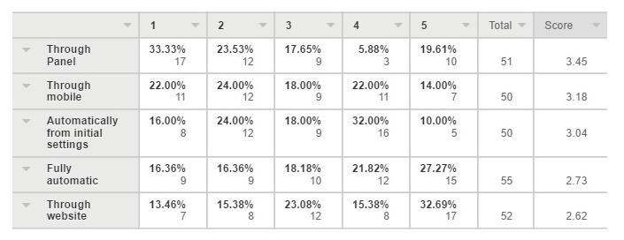

Table 7: Rating of different solutions

Overall the top 3 ways of regulating would be through panel, through mobile and then automatically from initial settings. The two least preferred methods are through website and a fully automatic solution. In average 51 replies were registered, and out of that 17 picked panel as most preferred solution. The second most preferred solution got 12 out of an average of 51 votes, and those are through panel, mobile and automatically through initial settings. This means that all top three solutions are viable as a possible solution to improving indoor quality for users.

# Summary:

From the survey on employees and students in Krona, we got some preliminary conclusion about the proposed HVAC control system.

* Most people are satisfied or neutral with temperature and humidity, but for the air quality, more people are unhappy with it.
* Temperature and fresh air are most important parameters for interviewees.
* People prefer to control temperature and air quality by themselves.
* People prefer to use panel and mobile as control methods.

According to the previous conclusion, the proposed system will pay attention to the follow functions.

* People will be able to control their indoor environment by themselves through the proposed HVAC control system
* The control methods will contain panel and mobile
* Parameters like temperature, humidity, air quality about indoor environment will be involved in the proposed system

# Annex

**The Survey Questions:**

1. Name: ___________________
2. Gender

|  |  |
| --- | --- |
| * Female | * Male |

1. Age

|  |  |  |
| --- | --- | --- |
| * Under 25 | * 25-45 | * Over 45 |

1. Are you satisfied with your indoor environment (temperature, humidity, air quality) like office, classroom?

|  |  |  |  |  |  |
| --- | --- | --- | --- | --- | --- |
| **HVAC parameters** | **Very Unhappy** | **Unhappy** | **Neutral** | **Satisfied** | **Very satisfied** |
| Temperature |  |  |  |  |  |
| Humidity |  |  |  |  |  |
| Air quality |  |  |  |  |  |

1. Choose up to three from the following parameters you find most important in your indoor. environment:
   * Temperature
   * Pollen / dust density
   * Humidity
   * Germs / bacteria density
   * Fresh air
2. Do you prefer to be able to regulate them by yourself?

|  |  |  |  |
| --- | --- | --- | --- |
| **HVAC parameters** | **Yes** | **No** | **Indifferent** |
| Temperature |  |  |  |
| Humidity |  |  |  |
| Air quality |  |  |  |

1. How do you want to regulate? Please rank them from most wanted 1, to least wanted 5.

|  |  |
| --- | --- |
| **HVAC Regulation means** | **Order** |
| Through Mobile |  |
| Through website |  |
| Through Panel |  |
| Automatically from initial settings |  |
| Fully Automatic |  |

1. Do you have any suggestions on how to improve your indoor environment?

-

-